Alexander Cannell

CSIS 2600

Rob Robertson

1. What I did is work forge an Ethernet cord.
2. What I Learned is that the length of the wire in the Ethernet cord needs to be long enough for the pins to pinch the wires. I also learned the wire pattern of a straight Ethernet, and a cross over cable.

Straight Ethernet

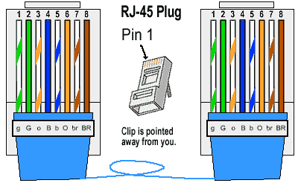

Cross Over Cable

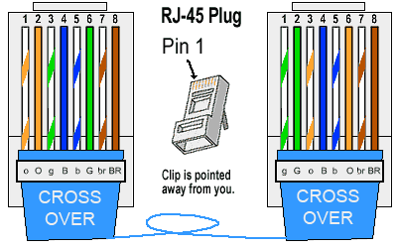

1. How does crafting an Ethernet cord applies to a network professional?